Principals Newsletter #1
3 February 2020

Welcome back to a new year of learning at South School. Students arrived today keen to share lots of really interesting stories about the break, adding they were keen to return and see friends.
This Principal newsletter is a new addition to our fortnightly newsletter aiming to keep our community up to date with all Education topics. You will find the newsletter on our website www.dannevirkesouth.school.nz .
In this first edition:
- Coronavirus
- Attendance
- South School staffing
- Block E (Rm 15, 16 and 17 upgrade)
- Polar fleece
- Hats in Term 1
Coronavirus
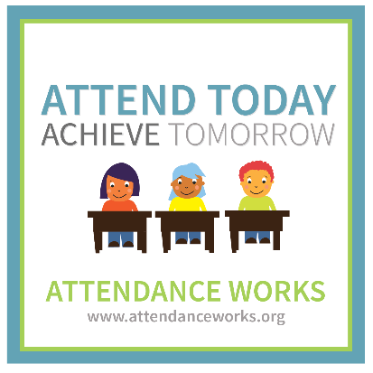
South School will be following Ministry of Health guidelines. Presently this includes requiring students who have recently visited or have had contact with others who have visited China, to not attend school for at least 14 days.
Attendance
We work with the Attendance Service to ensure students attend school when required to. We prefer to discuss with whanau how we can improve attendance rather than use the Attendance Service. If you do have concerns about attendance please make contact.
When a student is absent from school without notification:
Day 1  Text/phone call | Day 2  Further text mesaage and/or phone call | Still no response  Referral to Attendance Service if absence is unjustified | Attendance Service follow up
South School Staffing
We welcome two new teachers to our staff.
Room 11  Mrs Michelle Hewetson  Michelle has joined us from South Africa. | 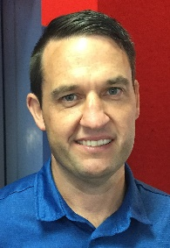  Tim Cranshaw has been employed in the new position of Learning Support Co-ordinator. More about how this new  position will help our students requiring additional support in the next newsletter.

Block E
The start date for the Room 15, 16 and 17 refurbishment has been delayed. We are using these spaces for teaching until further notice.
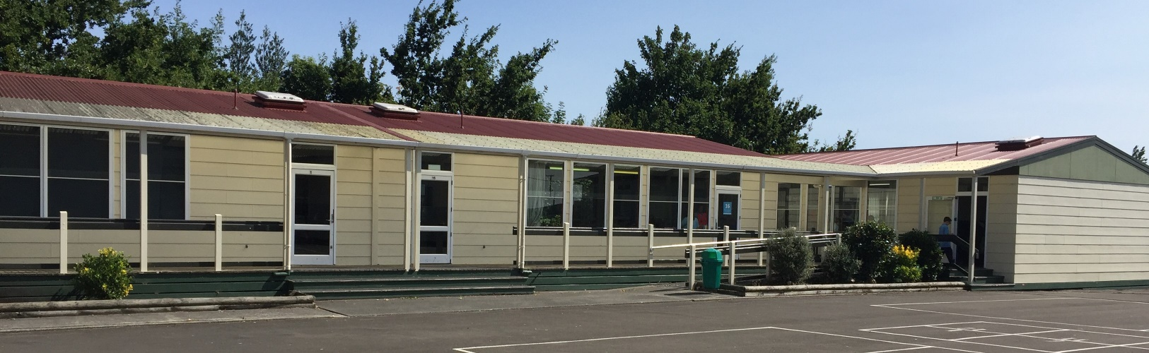
Polar fleece uniforms
We have a number of polar fleeces in good condition available for students who do not have one. Please see Phillipa when purchasing stationery this week.
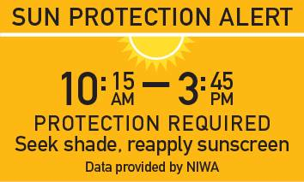
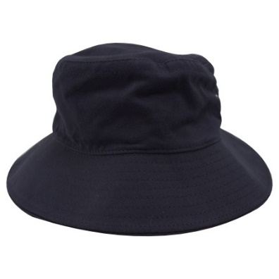
Hats in Term 1
A reminder that students must wear hats when outdoors in Term 1.

Stephen Snell
Principal

