Precautionary  Boil Water Notice | 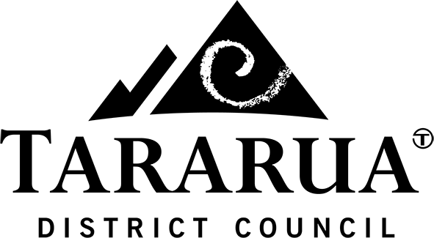

Dannevirke Water Supply, 15 September 2021
Tararua District Council has issued a precautionary boil water notice for the Dannevirke water supply. This is due to recent heavy rain resulting in turbid (dirty) source water, to the point where the existing water treatment plant cannot reduce the turbidity to levels required by the NZ Drinking Water Standards. It should be noted that no E.coli has been detected in the water.
Due to current challenges with Dannevirke’s impounded supply, we are current unable to take water from this when the source water is turbid. This was a known risk and repairs to the impounded supply are expected to begin this week pending weather conditions.
We apologise for the inconvenience this will cause and the team are monitoring the situation with the aim of removing this notice as soon as possible.
An update will be provided on Thursday 16 September.
Precautionary Boil Water Notice
Dannevirke Water Supply, 4.30pm Wednesday, 15 September 2021
Until notified, Dannevirke residents are advised to boil water before using it for:
- drinking (including making of sachet juice/drinks);
- making ice;
- food preparation;
- brushing teeth; and
- preparing infant/toddler formula.
Electric jugs with a cut-off switch can be used as long as they are full – allow the water to come to the boil and wait for it to switch off (do not hold the switch down to increase the boiling time). Water can also be placed in a clean metal pan and brought to a rolling boil for one minute. Boiled water should be covered and allowed to cool in the same container.
People with severely compromised immune systems, infants, pregnant women, and some elderly may be at increased risk. These people should seek advice about drinking water from their health care providers. If you have specific health concerns, consult your doctor or Healthline 0800 611 116.
If you have other houses or tenants on your property please advise them of the contents of this notice.
If you have any questions or concerns, please contact Tararua District Council directly on:
06 374 4080 or 06 376 0110
info@tararuadc.govt.nz
www.facebook.com/tararuadc
www.tararuadc.govt.nz

