Dannevirke South School SOS
Disco
Te Kakano and Te Tipu -
Come with your friends to dance and have fun!
Friday 9 December 2022 in our school hall
From 5.30 to 7pm

Wear fancy dress
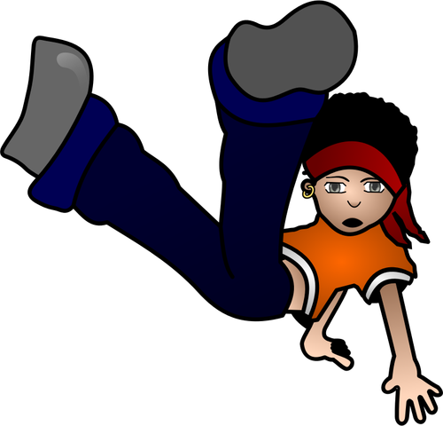
or
your favourite clothes.
Glow sticks for sale
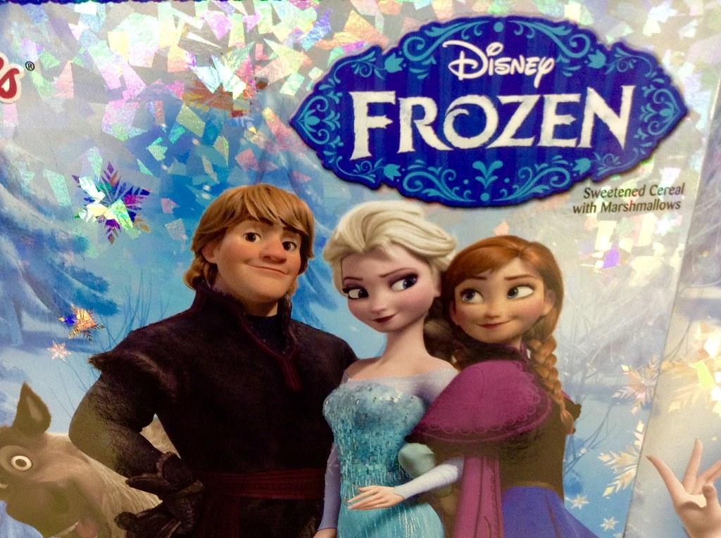
Food for sale…
*Sausage sizzle $2 * Water $1 *Drinks $2 *Ice blocks $1
*Chocolate bars $2 *Chips $2

